Appendix A: Submission Checklist
Public GIT (GitHub/Bitbucket/Gitlab) url:
Public API (Vercel or otherwise) url:
Task 1: Screenshot of your development environment setup:
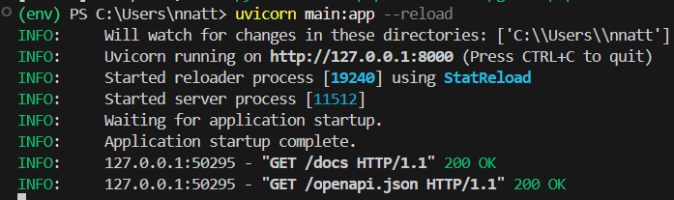
Task 2: Screenshot/s of your Mongo Database on MongoAtlas:
Task 3A: Screenshot of the API running on localhost in your browser:
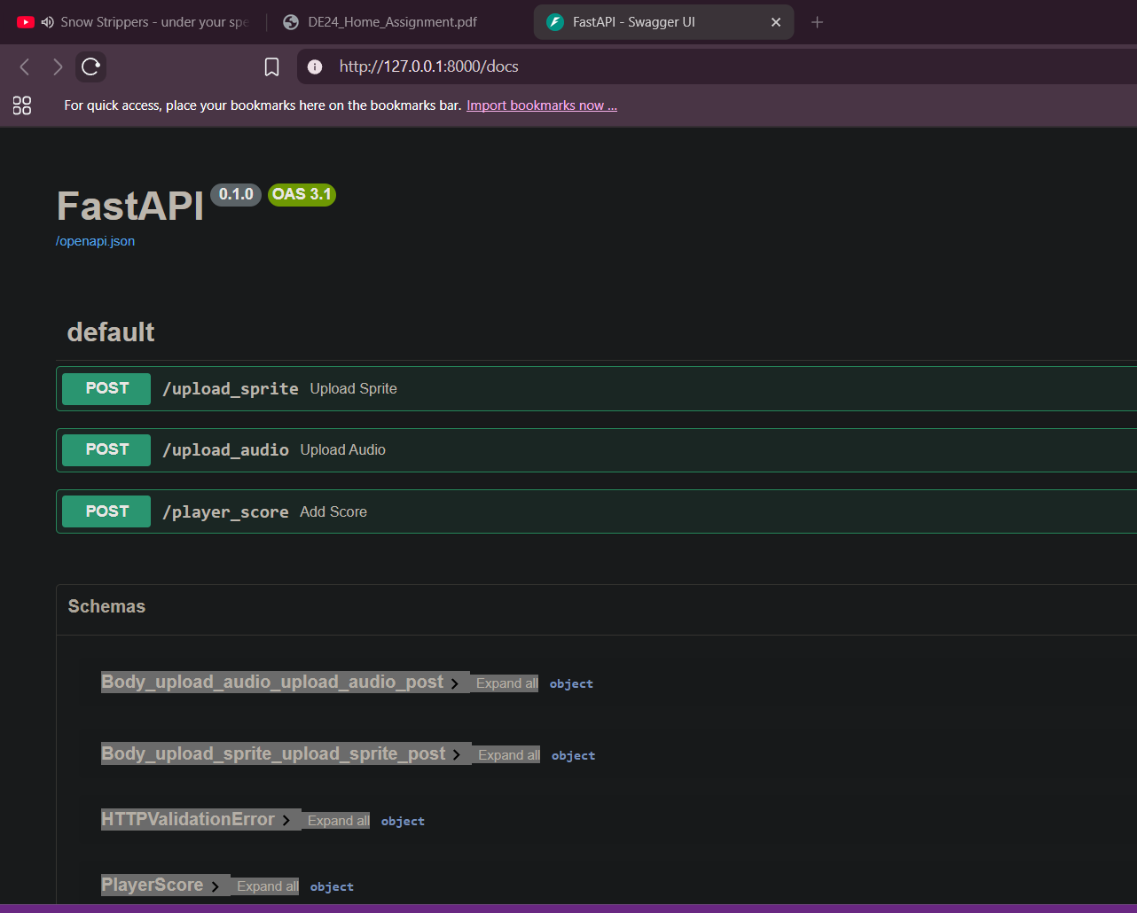
Task 3B: Screenshot of the hosted API running on a public url such as Vercel:
Task 4A: Screenshot showing credential setup:
Task 4B: Screenshot showing IP whitelisting:
Task 4C: Screenshot showing how you are preventing SQL injection:

